
Data Device Corporation
105 Wilbur Place
Bohemia, NY 1176
March 20, 2012

Mr. Doe
Company Inspector
2350 River Road
Farmingdale, NY 11735

Subject: Data Device Corporation Employment Information Report

Dear Mr. Doe

In response to the conversation with you we, Piter Garcia and Christine Johnson, are submitting the report on facts required by you. The purpose of this report is to provide useful information to xxx to be able to answer the assigned questions about the data device corporation and the opportunities offered in my field, engineering. The report includes an introduction, a list of answers to assigned questions, and concluding summary of all of the facts presented.

We will be staying in Long Island consulting job opportunities at Data Device Corporation, but if any changes need to be made we can work on the edits upon your request.

Courteously,

Piter Garcia
Computer & Electrical Engineer

Christine Johnson
Computer & Electrical Engineer

Enclosed: Company Information Report
Employment Information Report
Introduction
Data Device Corporation is an international leader in the manufacture of electronic components and responsible for the creation of innovative technology for the USA military and aerospace applications as well as other private companies all around the world. We, Piter Garcia and Christine Johnson, estimate that the employment opportunities at DDC are beneficial for Long Island and even for the state of New York. The employment prospects, job types, salaries, and educational levels offered by DDC have made easier for students about to graduate and graduated students in the engineering field to obtained practical experience and possibly a job, all depending on the person’s training outcome.
What are the employment prospects of DDC in the engineering field?
DDC has career opportunities for individuals who want to work in an atmosphere that is always renewed and fast moving. Actually, there are exciting employment opportunities for senior level process engineering professionals or a mid-level engineers looking for an opportunity to grow within an organization. Moreover, DDC is offering internships in different departments of the engineering field such as computer application and electrical engineering as well as availability to work afterwards depending on the student’s outcome.
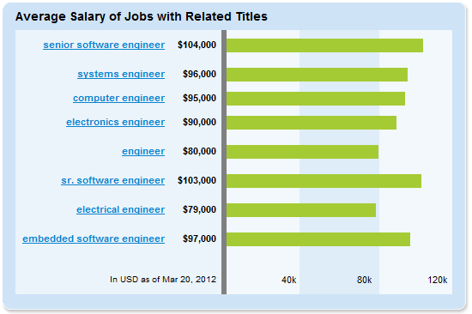
What types of jobs are being offered?
DDC’s current career opportunities are the followings: in the electrical engineering department process electrical engineer sr., and in the computer engineering department process computer engineer sr. For Internships the following departments are available: application engineer, software engineer, test engineer, electrical and computer engineer
The above chart is for the salary and jobs offered at DDC. Jobs positions whose salaries exceed 80,000 have experience requirements above the baccalaureate which are explained below. According to our report obtained from the online sources DDC possess more available positions, in the area of engineering, than others such as TELEPHONICS and others (Hired, 2012).

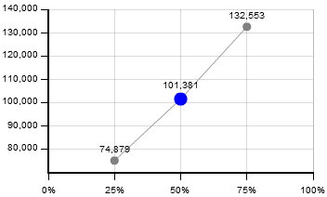
What is the salary range?
OTHERS TELEPHONICS DDC
Data Device Corporation offers attractive salaries and excellent benefits including 100% educational assistance, on-site comprehensive training for all employees and interns. For employees 401k, summer hours, casual dress, summer & year-end holiday shutdown, childcare subsidy, medical, dental, and vision. For intern a range from 17 to 25 dollars per hour.

What educational level is required for advancement beyond the baccalaureate?
The requirements for an advancement position beyond the baccalaureate are: First, masters in Material Science, Mechanical Engineering or electrical Engineering. Second, a minimum of 5 years of experience in surface mount, and hybrid process technologies. Next, must have knowledge of Mil Studs 883, 38510, or IPC 610 desirable. Also, must know about Statistical Process Control (SPC) and Design of Experiments (DOE) desirable. Third, needs to have strong interpersonal and communication skills. Finally, must be proactive in seeking solutions to potential problems or inefficient processes, and able to work independently with minimal supervision (SalaryExpert.com, 2012).
How much experience is needed to advance?
Data Device Corporation offers on-site comprehensive training for all employees and interns. Therefore, the experiences you need to become part and advance within the company in the engineering field are as follow: all basics regarding to the electrical and computer theories, a bachelor or about to graduate in any engineering or related field, a history of academic and professional success, and be a trouble shooter.
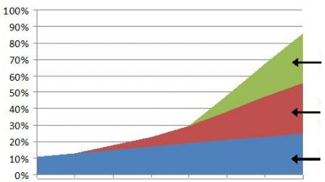
Companies such as TELEPHONICS and others have job positions that are difficult to get due to their experience requirements. These companies provide many internships, however the probability for a student obtain a job position at such company are very low since their experience requirements are very high level for an engineer that is a beginner.
OTHERS
DDC
TELEPHONICS
Chart of job possibilities due to experience requirements

Summary

Our Data Device Corporation employment report has proven that this company has been beneficial for Long Island and even the state of New York by providing internships with a good salary and flexible schedule as well as job positions that are easy to obtain, but mainly depending on your training outcome. We, Piter Garcia and Christine Johnson, have shown throughout sources that the employment prospects, job types, salaries, and educational levels offered in the engineering department by DDC possess one of the highest raking in Long Island due to their job specifications and requirements; which are not as strict and high level, for engineers that beginners, as other engineering based companies in Long Island and New York area.

Works Cited

Corporation, D. D. (1995-2012 , March 20). LEADERSHIP BUILT ON OVER 45 YEARS OF INNOVATION. Retrieved March 20, 2012, from Data Device Corporation: http://www.ddc-web.com

Hired, S. (2012, March 20). http://www.simplyhired.com/. Retrieved March 20, 2012, from Engineer Salaries in Long Island City, NY: http://www.simplyhired.com/a/salary/search/q-software+engineer/l-long+island+city,+ny

SalaryExpert.com. (2012, March 20). http://www.cbsalary.com. Retrieved March 20, 2012, from Engineer Salary in Long Island, NY: http://www.cbsalary.com/salary-calculator/chart/Electrical+Engineer/NY/Long+Island?specialty=Electrical%2bEngineer&pf=true&cty=Long%2bIsland&kw=Electrical%2bEngineer&jn=JN004&tid=4029&sid=NY

